PROJECT PROPOSAL

NIHVA TECHNOLOGIES PVT. LTD.
187, G-Block, Thermax chowk, Above Renault Showroom, MIDC
Chinchwad, Pune – 411019.

Customer Name | Minda Industries Ltd
Project Name | SIDE STAND SENSING SWITCH BATCHING & PACKING LINE
Project Location | UNO, Pune
Contact Person Name | Mr. Manish Gupta
Email Id | guptam@mindagroup.com
Contact Number | +91-7410049522

For Technical: -

Contact Person: Mr. Shailendra Saindane
Mob No.: +91-7709209333 / 9168423687
Email id: automation@nihva.com
Web: http://www.nihva.com

Project Title: SIDE STAND SENSING SWITCH BATCHING & PACKING LINE
Date: 04/12/2018
Quotation No. SQT/18-19/1005
Dear Sir,

Thank you for the opportunity and trust shown on “NIHVA” your preferred partner for innovative solutions. This has reference to your above-mentioned requirements as well as our subsequent communication; please find below our best offer.

A. Requirement:
Packing of chili powder pouches of different sizes. Require process is as below.

Process Flow Chart:

MAGNET TESTING & NUMERIC PUNCH ENGRAVING

MANUAL LOADING IN FEEDER UNIT

PRODUCT COUNT (100 NOS) ON BUCKETT CONVEYOR

FLOW WRAP: POUCH MAKING & LOADING OF 100 NOS JOB WITH POUCH SEALING

STICKER PASTING ON POUCH

Product Details:
Details
Pack size | 40 x 35 x 10 mm  L x B x H
Machine output | 80 Pouches/min
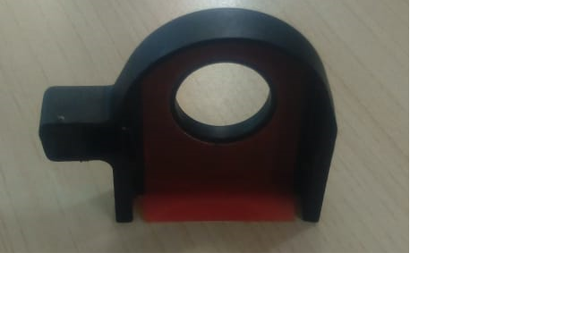

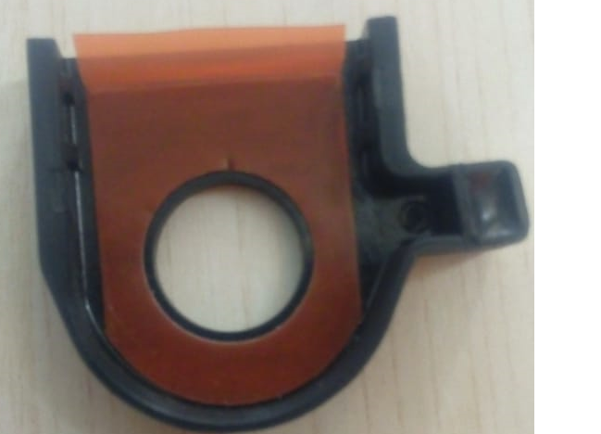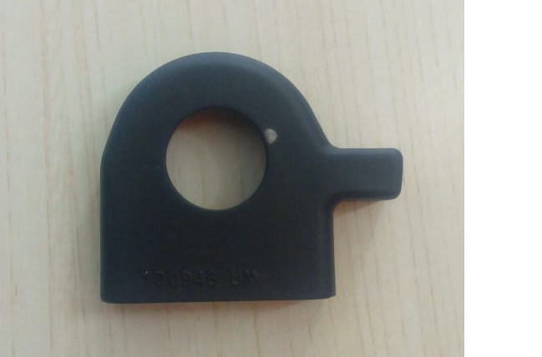

Technical Specifications: - (Packaging line)
Sr No. | Packaging System Description | UNIT | QTY
1 | Bowl Feeder |  | 1 Nos
 | - Dia | 750mm
 | - height | 650 mm
 | - Structure height | 500 mm
 | - Construction | MS powder coated
 | - Contact Part | Zinc Plated
2 | Flat Belt Conveyor |  | 1 Nos
 | - Conv. Width | 75 mm
 | - Conv. Length | 1000 mm
 | - Construction | MS Powder Coated
 | - Contact Parts | Zinc Plated
 | - Motor | Bonfiglioli (IE2)
3 | Bucket Conveyor |  | 1 Nos
 | - Conveyor Width | 250
 | - Length | 1000mm
 | - Construction | MS Powder coated
 | - Contact Parts | Zinc Plated
 | - Motor | Bonfiglioli (IE2)
4 | Batching & Packing Machine |  | 1 Nos
 | - Machine Dimensions
 | - Width | 1300
 | - Length | 2500
 | - Conveyors in machine
 | - Width | 250
 | - Construction | MS Powder Coated
 | - Contact Parts | Zinc Plated
 | - Pneumatics | SMC
 | - Motor | Bonfiglioli (IE2)
5 | Flat Belt Conveyor |  | 1 Nos
 | - Conveyor Width | 500
 | - Length | 500
 | - Construction | MS Powder coated
 | - Contact Part | Zinc Plated
6 | Ink Marking Machine with fixture |  | 1 Nos
 | - Make: Markal
 | - Fixture: Nihva
7 | Electrical Control Panel |  | 1 Nos
 | - Electrical VFD & All material Required: Siemens
 | - Field wire: Polycab
 | - Sensors: Keyance & Wenglor

Images: -

- Bowl Feeder: - 3. Flat Belt Conveyor: -
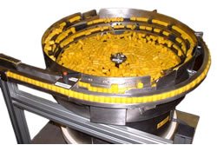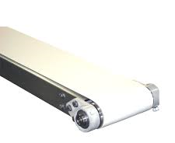

- Bucket Conveyor: - 4. Ink Marking Machine with fixture:-

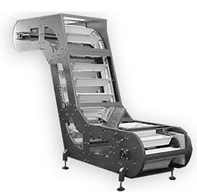
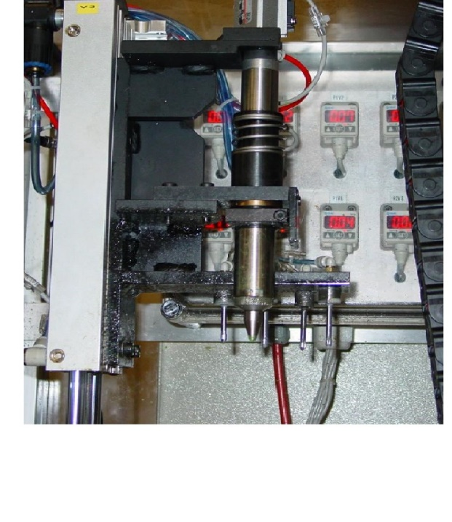

Commercial offer: -
Sr no | Description | Qty | Unit
1 | Bowl feeder | 1 | Nos
2 | Flat belt conveyor | 1 | Nos
3 | Bucket Conveyor | 1 | Nos
4 | Batching And packing machine | 1 | Nos
5 | Flat belt conveyor | 1 | Nos
6 | Ink Marking Machine with fixture | 1 | Nos
7 | Electrical Control Panel | 1 | No
Cost of Project in INR |  | 22,95,000/-

GST PUNE: 27AAECN0437H1ZM

E. Drawings Training and warranty

Drawing:
We will issue a full set of drawings for approval within 2 weeks of receiving the confirmed order and finalized design details.

Training:
After installation of the Conveyor system, we will train the Clients personnel in the operation and basic maintenance, including the understanding of the error codes on the control system (if applicable).

Warranty:
- The warranty period is twelve months from the date of installation and commissioning.
- If a defect arises within the warranty period stated, which is attributable to faulty design,
- materials or installation workmanship the product will be repaired at our discretion without charge.
- This guarantee is subject to proper use of the product and assumes that the product is regularly serviced and maintained by skilled personnel in accordance with the operation and maintenance instructions supplied.
- Maintenance & Service Agreement:
- We would suggest that you take advantage of a maintenance and service agreement on the NIHVA products, which will guarantee trouble free operation and speed of response in an emergency. Customized proposals are available on request.
- We are pleased to inform that we also undertake AMC for all of our products & for any of your existing facilities.
- Maintenance and service aren’t about what you get. They’re about what you avoid: failures, losses and unplanned interruptions.

- Client Scope:
- Unloading from truck placement on site.
- Exiting/Repair/ Modification/ Refurbishment charges will be extra

G. Terms and Conditions: -

- Price : Ex. Works Pune
- P & F : 3 % Extra at the time of delivery.
- Freight Notes : Extra as applicable.
- Delivery : Within 10- 12 weeks from date of receipt of
confirmed purchase order, advance payment,
drawing approval.
- Payment Terms : 80% advance along with confirmed purchase
order balance 20% before dispatch.
- Insurance : Extra as applicable.
- GST : As Applicable on total supply value.
- Validity : 15 days from date of quotation.
- Warranty : 12 months from date of supply.

Please feel free to contact Mr. Ravi Ranjan Prashad - +91-7709586333 for any further clarification in this concern.

With Best Regards,
Pratiksha Prajapati
+91-7219207333
For NIHVA Technologies Pvt Ltd

